Difference between @controller @restcontroller @component @service @repository

All are used to create beans but they have some hidden differences.

What is annotation?

Spring Boot Annotations is a form of metadata that provides data about a program. In other words, annotations are used to provide **supplemental** information about a program. It is not a part of the application that we develop. It does not have a direct effect on the operation of the code they annotate

All the above annotations are stereotype annotations

Stereotype annotations are special type of label or tag that developers put on classes to tell spring something about the role or purpose of the class . These annotations helps the program understand how to treat and use classes

Classes annotated with stereotype annotations are automatically registered as Spring beans during the component scanning process.

While other non stereotype annotations or custom annotations donot automatically trigger bean registration

Here @Component is the parent annotation and @controller @restcontroller @service @repository are child they are just alias of @Component if you open all this source you can see its parent as component as below

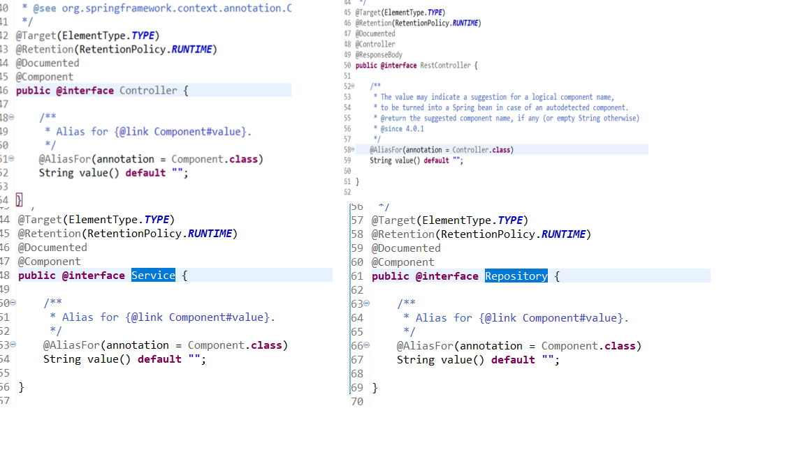

@Controller and @RestController are used to handle http requests and are applied at the class level we cannot replace these with just @RequestMapping bcoz this annotation doesn’t create bean

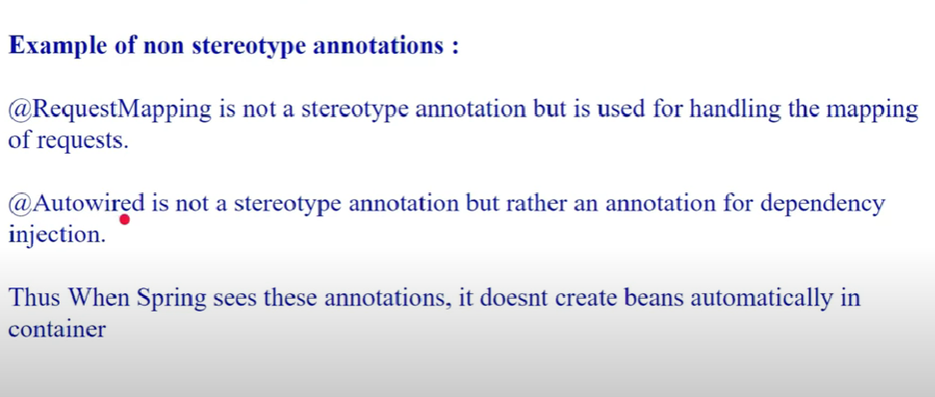

@Service is added at the class level adding this doesn’t add any specialization to the class it is used just to define that it contains code related to business logic

@Repository any class annotated with repository states that it holds code related to DB operations

The benefit of using @Repository is that it enables spring exception translation mechanism.

This mechanism catches checked exceptions related to persistence and translates them into spring’s DataAccessException which is run time exception. With this we donot have to explicitly specify try catch for exception handling related to DB exceptions.

PersistenceExceptionTranslationPostProcessor is responsible for this

